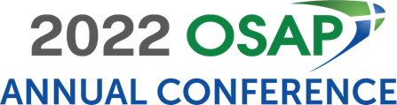
Dear <Supervisor’s Name>:
I would like to purchase the 2022 OSAP Annual Conference on-demand recordings.
The 2022 OSAP Annual Conference will provide vibrant programming on emerging and salient topics in dental infection prevention, occupational health, and patient safety.
After reviewing the course materials, I have identified several educational sessions that will allow me to gain knowledge and understanding about how we can improve our internal processes related to patient and provider infection control and safety. The presentations are facilitated by scientific experts and oral health colleagues who have faced similar challenges and are directly applicable to my work. I specifically chose these presentations because they directly relate to <insert issue your facility is currently dealing with>.
- <insert the session title and description>
- <insert the session title and description >
- <insert the session title and description >

Additionally, I will have the opportunity to earn up to 17.5 CE credits.
I am seeking financial support for the registration fee for the on-demand recordings. Since I will access the sessions online, there is no additional expense for travel, accommodations, or food, making this a cost-effective educational experience. If I register by Thursday, April 21, I will be able to take advantage of the early-bird rate of $615 (OSAP Member)/$775 (Non-Member).

The opportunity for me to gain knowledge in specific areas of my job makes my purchase of the 2022 OSAP Annual Conference on-demand recordings a wise investment. Please consider my participation. I’ll be glad to provide any additional information that you need to make a sound decision.
Sincerely,
<your name>

